ASTOR BOYS & GIRLS UNIFORM LIST - 2024
DESCRIPTION | SIZES | PRICE
Boys & Girls  Black blazer with embroidered school logo | Chest: 28” or 29”  30” or 31”  32” or 33”  34” or 36”  38” or 40” | £35.00  £39.00  £39.00  £39.00  £44.00
Plain Black v/neck jumper | Chest: 30” 32”  34”  36” 38” 40” | £16.00  £17.00  £19.00
Boys plain Black trousers | From £12.50
Girls plain Black pleated skirt | From £18.00
Boys’ White shirts  (TWIN PACKS) | Collar size: 13”,13h,14”,  14h, 15”, 15h | £16.00  £19.00
Girls’ White blouses  (TWIN PACKS) | Chest: 30” 32” 34”  36” 38” | £16.00  £19.00
Boys sports top  Black + Amber | Chest:  30/32, 34/36  38/40, 42/44, 46/48 | £22.00  £24.00
Plain Black sports shorts | Waist: 22/24, 26/28, 28/30  30/32,34/36,38/40 | £5.00  £5.50
Plain White polo shirt | Chest: 30”, 32”  34”, 36”, 38”,40”,42”,44” | £8.99  £9.99
Plain Black sport socks | 3-6  7-11 | £5.00  £5.50
IRON ON Name Tapes | Quantity :50 | £5.50
Craft apron | One size | £5.50
Shin pads | YTHS OR MENS | £11.99
Gum shield | Jnr/ Snr | £3.50
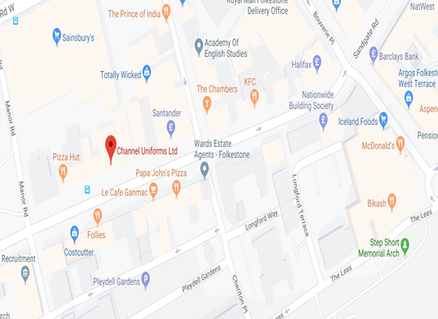
118 Sandgate Road
Folkestone Kent CT20 2BW
01303 487075
E-mail channeluniforms@live.co.uk
www.channeluniforms.co.uk
Telephone orders welcome

OPENING HOURS
Sunday Monday closed.
Tuesday –Friday 9.30 - 5.00pm
Saturday 10.00 – 4.00pm

